Welcome to the German Informative Inventory Report 2023 (IIR 2023).
This report covers the preparation, maintenance, and improvement of the German air pollutant emission inventory.
Emission estimates are provided for the timeseries from 1990 to 2021, with exceptions for Particulate Matter ≤2.5 and ≤10µm (PM2.5 and PM10; as of 1995) and Black Carbon (BC; as of 2000)
TABLE OF CONTENTS
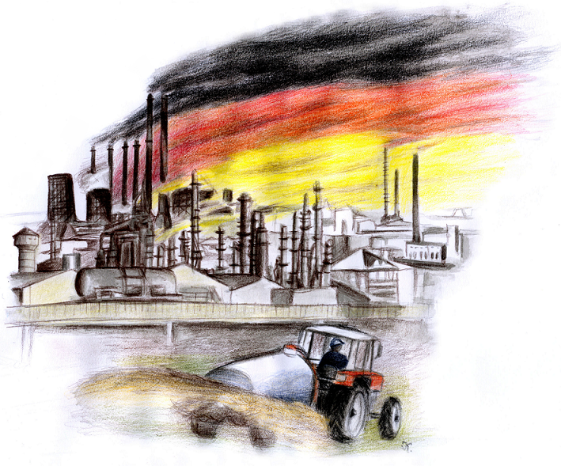
IMPRINT
Publisher:
UMWELTBUNDESAMT
WOERLITZER PLATZ 1 | 06844 DESSAU-ROßLAU
PHONE: +49 (0)340-2103-0 | FAX: +49 (0)340-2103-2285 | E-MAIL: buergerservice[at]uba.de | INTERNET: www.umweltbundesamt.de
Report to be completed in: April 2023
Edited by: SECTION V 1.6 - EMISSION SITUATION | editor-in-chief: Michael Kotzulla
Dessau-Roßlau 2023

