NFR 11 - Other Sources

11.C Other Natural Sources

Short description
NFR-Code | Name of category | Method | AD | EF | Key Category
11.C | Lightning | T1 | NS | D
Lightning and corona discharge during thunderstorm events cause atmospheric chemical reactions to take place at high voltages and high temperatures. These reactions cause the production of NOx in the atmosphere.

Methodology
The calculation of NOx emissions from lightning uses strike counts from the German weather service and default emission factors from the EMEP/EEA guidebook.
For the complete time series, the emissions are calculated as follows:
EM = AD (number of lightning strikes) * EF (kg emission per strike)

Activity data
The number of lightning strikes in Germany is taken from a commercial system called “BLIDS” run by Siemens. The data has been cross-referenced with information from the German weather service. Consistent strike count data is available from 1992 onward and has been back-populated to cover the full time series since 1990. The following table shows the strike figures over time.
Table 1: Lightning strikes in Germany from 1990 onwards
Year | Strike count [1000 strikes]
1990 | 443
1991 | 443
1992 | 370
1993 | 274
1994 | 429
1995 | 394
1996 | 218
1997 | 255
1998 | 428
1999 | 589
2000 | 1,026
2001 | 591
2002 | 1,023
2003 | 813
2004 | 741
2005 | 802
2006 | 1,001
2007 | 1,139
2008 | 990
2009 | 917
2010 | 589
2011 | 687
2012 | 656
2013 | 542
2014 | 623
2015 | 550
2016 | 432
2017 | 443
2018 | 446
2019 | 329
2020 | 399
2021 | 512

Emission factor
For the calculation of emissions in this category, the Guidebook emission factor of 2.75 kg NOx per strike is used.

Emission Trend
The emission value is solely dependent on the strike count and varies between 1 to 2 kilotons of NOx per year.
Figure 1: NFR 11.C, NOx emissions from lightning
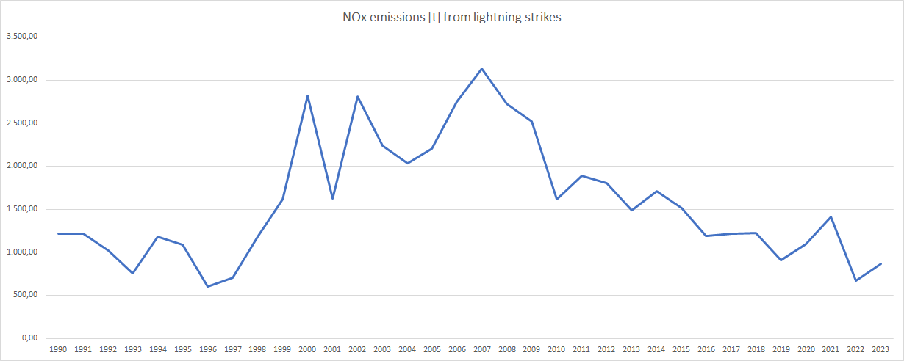

Recalculations
As these activities and emissions are reported for the first time, no specific recalculations occur against a previous submission.

Uncertainties
The AD from BLIDS does have a low uncertainty of ± 3%. The uncertainties for the emission factors are estimated to be relatively high, being a default value. Hence the overall uncertainty for the emission estimation of NOx from lightning is qualified estimated by expert judgement to be high (>50%).

Quality checks
No sector-specific quality checks are done.

Planned Improvement
Currently no improvements are planned.

