State of the German POP inventory
Generally, and despite a lot of improvements implemented in recent years, the German POP inventory is still incomplete. There are some source categories missing, in particular those where data availability is an issue. Measurement data for POP emission factors is hard to come by, and where available these are regularly annotated with high uncertainties. Moreover, creating consistent time series for POP emission factors is challenging, even for sources with EFs measured recently, since historic data (e.g. for 1990) is even harder to find. Not in any case it's possible to fill the gaps with default values, since default POPs emission factors are often very high and not in line with German legislation. In such cases, the default value would be an important source of inconsistency, which may cause an infringement procedure.
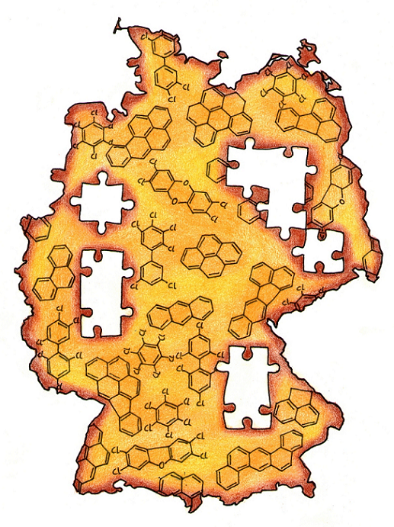Illustration POP inventory

Current reporting
The quality of reporting varies greatly inside the POP inventory, depending on the (group of) pollutant in question:

Dioxins/ Furans
Due to current legislation, data availability is relatively good. There are measurement data for waste incineration plants and steel industry installations both for 1990 and current years. Therefore, the two most important sources are well covered. For small combustion (in particular wood), where total activity and emissions increased in recent years, measurement data is available. These emission factors come with high uncertainties, since dioxin emissions depend largely on the fuel used and on combustion conditions. Since we have to cover about 9 million small wood combustion installations in Germany, it is hard to model a consistent usage pattern. Furthermore there is a high degree of uncertainty regarding the quality of the firewood, which is used in small combustion plants. Actually the fuel quality is required by law, controlled by the chimney sweeper. However, illegal waste wood burning cannot be averted. But it's not possible to estimate the resulting emissions. Despite these problems, the German POP inventory is reasonably complete for dioxins and furans. The only known missing sources are small scale waste burning (in particular gardening waste burning) and accidental fires (which are very hard to quantify regarding dioxin emissions). Both small scale waste burning and fires are considered to show a decreasing trend and to be less common then in other counties.

PAHs
PAHs result from incomplete combustion. The by far most important source category in the German inventory for PAHs is small combustion. The same problems as for dioxins apply: emission factors are available but show high uncertainties, usage pattern are hard to model and regulate. Other sources include steel and mineral industry, power plants, and waste incineration plants. The quality of emission factors for these categories is very diverse. Moreover, different PAHs are given for different sectors (Borneff, US EPA, or others). For the 4 expected single substances, very few data are available, with the possible exception of benzo(a)pyrene. As a result, the PAHs emissions in the inventory are likely to be overestimated. Overall, the German PAH inventory is quite complete, since most emission come from relatively well regulated combustion processes. As for dioxins and furans, small scale waste burning and forest fires are not covered.

HCB
Data availability for HCB is considerably worse than for dioxins/furans and PAHs. The pollutant is currently not measured at installations, since it is not subject to regulation. Therefore, the German inventory uses mainly default factors from the EEA/EMEP Guidebook, which do not fit well into time series. In addition, some important sources are missing, such as HCB emission from smoke munitions. With submission 2016 HCB emissions from pesticide use in the agricultural sector are reported the first time. Other categories that might have HCB emission, but are currently not covered due to missing measurements include chemical industry, metal industry and cement production. Nonetheless, some country specific emission factors for key categories are available.

PCBs
PCBs from waste incineration is well covered and regularly measured at facility level due to current legislation. Data availability is appropriate. For other industry sectors very few measurements are taken and, again, have considerable uncertainties. In particular information for 1990 is hard to come by, rendering the creation of a consistent time series a tough task. All together, the data availability is slightly better than for HCBs. Nevertheless, the PCB inventory is still incomplete and misses out on probably important source categories, such as PCB emissions from electrical equipment (capacitors and transformers). Furthermore, in Germany mainly the Ballschmiter value is measured, which is: (PCB 28, 52, 101, 138, 153, 180 )* 5. In contrast to the WHO 2005: (77, 81, 126, 169, 105, 114, 118, 123, 156, 157, 167, 189) TEQ. The measured congeneres are completely different. On the basis of currently available information (only a few measurements), Ballschmiter PCBs seem to be remarkable higher than the associated WHO TEQ.

Future improvements
The first step towards an improved German POP inventory is to thoroughly check existing information (mainly EFs), to bring these up to date and to identify sources and pollutant combinations that need new measurements most. Correlation to immission data (POP trends measured in the local environment) can help to check for trends to be expected for each pollutant. Examination of regional differences in immission data can also give clues pointing at key categories. Working closely with the industry, the German inventory team already had the chance to improve some sources and acquire measurement result for some categories (e.g. HCB from waste incineration and the copper industry). This work should continue. More generally, the goal should be to carry out new measurements in respect to the priorities identified in step 1. This is of course subject to resource availability, since POP measurements are quite expensive. The new measurements should cover the whole spectrum of POPs in order to get a consistent resulting inventory. More knowledge on the relationship between different POPs (in terms of values for emission factors) would possibly allow to close gaps and to infer on historic values currently not available.
Due to the lack of measurement data it's necessary to collect all available information and to exchange experiences at international level. Therefore the “informal network of POPs inventory compiler” is a good opportunity for all participants to varify inventory data.

